**Assignment 4 Executive Summary**

The goal of this analysis was to modify the length of reviews, modify the training samples, validation samples, and limiting the model vocabulary to understand the effects on model performance. In this assignment, you can definitely see a difference in making these changes.

**Findings for Each Step in Model Development**

1. **Cut off reviews after 150 words:**
   1. Training- Accuracy: .92, Loss: .24, Val. Accuracy: .85, Val. Loss: .34
   2. Test - Accuracy: .84, Loss: .36
   3. In limiting the reviews to 150 words, the accuracy for the training is higher vs for the validation and test sets of data, which would suggest that the model is overfitting on the training set, and suggests that limiting reviews to 150 words is hindering the models performance.
2. **– 4. Restricting training samples, validating on 10k samples, and looking at the top 10k words, led to the following:** 
   1. Training – Accuracy: .94, Loss: .2, Val. Accuracy: .947, Val. Loss: .17
3. **Consider an embeddening layer, and a pretrained word embeddening – which is better? Also change number of training samples to determine what point the embeddening layer gives better performance:**
   1. My accuracy for my embeddening layer was only .51, and the loss was .69. For the pretrained layer, it was slightly worse, which surprised me, but I did make changes to help this run faster. Accuracy for the pretrained version was .49, and loss was again .69.

**Recommendations:**

After running several scenarios of all models, I would recommend using a pretrained embeddening layer, while not limiting the number of words in each review. As far as training samples goes, I would keep the number at 10,000 at a minimum, as more samples keep the accuracy higher than when limiting the samples arbitrarily.

**Appendix:**

Relevant charts

1. Baseline: 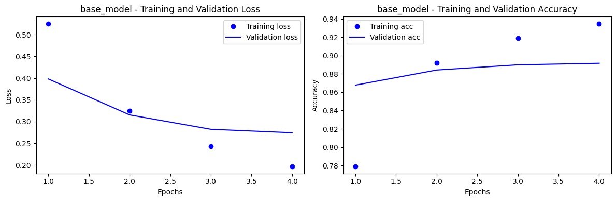
2. Cut off reviews after 150 words:

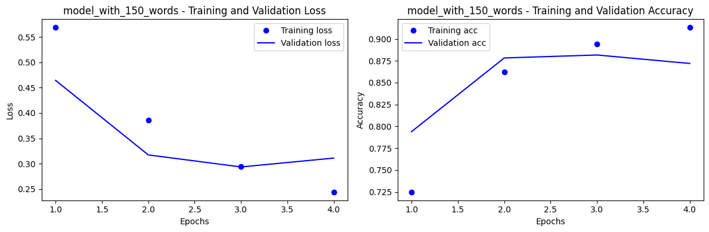

2,3,4:

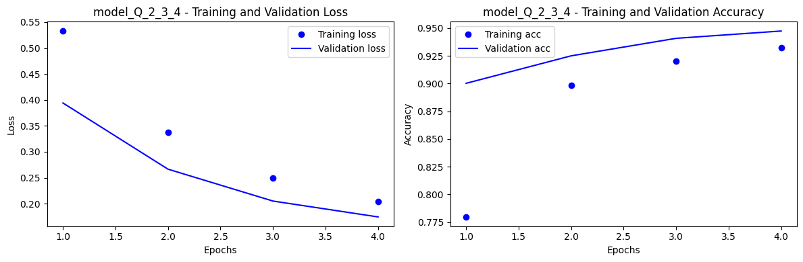

Trained Embeddening:

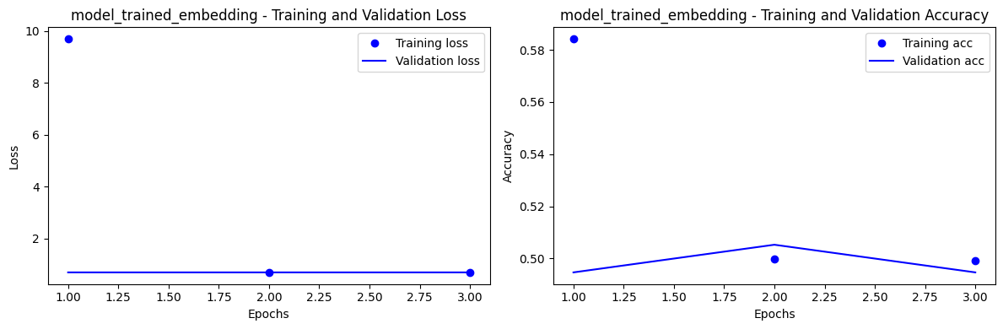

Pretrained Embeddening:

